4483 Game Design

Individual Game Critique

Borderlands 2

Reid Jackson

250914839

**General Information**

The Borderlands Series, and more specifically Borderlands 2 was developed by Gearbox Software, and published by 2K Games, along with Xbox Games Studios and Sony Interactive Entertainment, for the Xbox and PlayStation respectively. The platform used to review this game will be Microsoft Windows. Borderlands 2 is a hybrid of two main genres, first to the action-role play game (aRPG) and it is a first-person shooter (a looter-shooter more specifically). The series is targeted towards a more mature audience (18+), given its violence, gore and strong language. Although, its cell-shaded style also helps it appear to cartoon-like for younger audiences. It is also targeted towards the North American and European markets, due to its genre, and the style of gameplay, although some overlap could occur due to the aRPG aspect with an Asian audience.

**Game Overview**

A loot-splotion in effect
The core gameplay of the Borderlands games is loot. The main drive for many players is seeing the coined term “loot-Splosion”, killing a boss or opening chests to see a shower of weapons, mods, class items and other valuables the weapons-system has to offer. One of the driving mechanics is the infinite possibilities the weapons can have, such as a shotgun with a sniper-scope or a magnum that shoots rockets. This variety lets players have guns that suit their playstyle or give ones that are so unrealistic and unique that they keep just for the sake of having it.

A loot-splotion in effect

On top of weapons and loot, the player customization and leveling offers a deep and customisation way to play the game the way the player wants. Starting the game, the player chooses from one of several classes, and in each class, there is a subclass that tailors to a different playstyle even with that. This gives players a lot of choice and flexibility in how they approach encounters and how they generally go about the game.

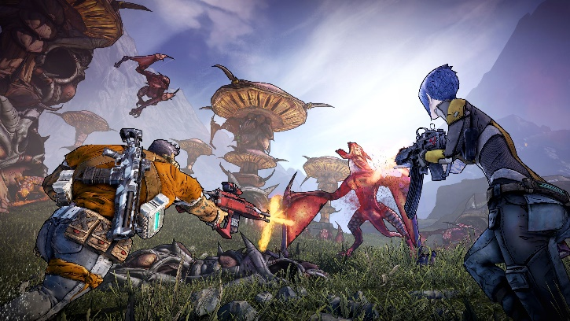 As previously mentioned, the visual style of the game is cell-shaded giving it the unique “Borderlands” look. It gives it just enough realism to look visually impressive, but also cartoon-like so that it still feels unserious in nature, after all, it is Borderlands. The audio style of Borderlands 2 is hard to quantify, it is slightly futuristic version of western-style music. This adds to the wild-west wastelands style of the game but follows the time period of the game (futuristic, but almost post-apocalyptic).

Visual Style

The game follows “Vault Hunters”, adventures in search of loot and treasure. These Vault Hunters scour the wastelands of Pandora, a dangerous and violence ridden world. Along the way they make allies to help defeat a common enemy, Handsome Jack; a narcissistic, militaristic leader focused on opening the Vault for untold riches and weapons. These Vault Hunter(s) and their allies, try to find a way to stop this from happening at all costs.

**Game Critique**

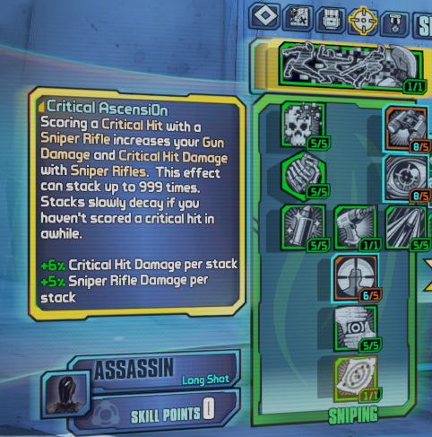The game was fun, it offered a rich and interesting narrative, along with a fun and stress free (for the player) world. The story drew me in and drove me to keep playing to see the events unfold. The world was open, immersive and full of quests and characters to talk to and explore, it gave a sense of my own playstyle to progress through the game. I chose Zer0, a sword-wielding assassin that can go invisible, and my subclass choice was sniper/critical hit (headshot) focused, given me massive bonuses to sniping and headshots, letting me ‘splode some heads (and loot).

The game provided a good pace of progression and enemy diffucty (tied to their level), my level stayed roughly in range of the enmy level based on the new areas, with new areas having higher level enemies than the last. This provided a gameplay experience that the enemies were always tough enough where I wouldn’t just run in and hope for the best, but not so hard that death was too common to enoy the laid back feel of Borderlands. Though, at somepint during the game my level jumped consideralby compared to enmies and iwas basically a walking god; however, this was fun to see the fruits of my labour pay of and be a god of death to the bandits of the world.

I would play this game if it wasn’t part of my assignment, I very much enjoy first-person shooters and RPG’s, and Borderlands is a hybrid of the two with an interesting twist on visual style, and gameplay. I would have sought it out eventually based on the genres alone.

Already said it, loot-splosion is the word I’d describe Borderlands 2 with, loot and guns *everywhere*.

This would be a good game of the target market, it gives a wide ranges of core aspects that many different types of players will enjoy, min-maxing builds, exploration and secrets, casual play, cooperative play, character and skill choice and customization. These aspects will appeal to many different types of players, and the style of gameplay and characters effectively target the aforementioned audiences.

The mechanics of the game motivate players to continue playing, the story for one part draws the palter in to continue and find out what happens to the world on Pandora. The other is the appeal and allure of loot, that next insane gun the boss or chest might drop or a key item to improve or finish the build will keep the player saying, ‘just one more quest’. It differentiates from its competitors with its loot explosions and the limitless weapon builds that can be generated.

The visual cell shaded style of the game has been coined the ‘Borderlands’ style, especially when the first Borderland s came out, it stood out from other large releases just for that fact alone. The world and the monsters and the well-known Borderlands bandits, give the game a hilarity that you just don’t find anywhere else. It doesn’t try too hard to be funny or over the top (though the game does do that well), it’s its own style of game that tries to be different (in a good way).

The games key strength come from the choice to stand by what the games do best, hilarious, laid back and over the top, with a deep story and *lots* of loot and quests to go chase. What I enjoyed most about the game was creating my own build and weapons to travel the badlands. The world is diverse in landscape always giving a new place to go and monsters to see.

Its key deficits come from the lack of true control over weapons, the loot-splosions are awesome and give you lots of opportunity for something new or strong, but ninety-nine percent of it is cannon-fodder, destined for the vendors to sell. They’re all random, giving a difficult time for player searching for a specific type of weapon, and on top of that the perks that they want with their build.

Improvements to the game would come in a form of being able to focus on certain weapons dropping, possibly dropping chances of ‘good perks’ or archetypes but at least a clearer path to a desired weapon. Another point of interest for me is the subclasses, you’re locked into one specific subclass, where you may like perks of different subclasses, but you’re funnelled into only using one. A unified skill tree with investments into different paths to get desired perks/skills.

**Final Analysis**

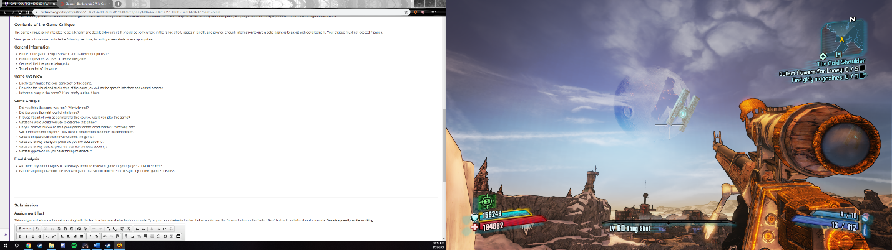Other insights I’m taking way from the game are the enjoyment of fighting the enemies. The different types of enemies how they interact with the player and fight give a depth to the combat. Other than bosses, enemies don’t feel like bullet sponges or to ‘squishy’ unless they are small cannon fodder, but the variety of enemies and having to deal with them makes the combat interesting in every encounter. The level design is also another large one, the flow of encounter spaces allow for each type of class to play to it strengths, open spaces area of effect, close questers areas and vantage points for distant fight all give players choice in how they approach things. Both aspects will influence how I create my game and make me reflect on how the player enjoys or will want to enjoy the game rather than forcing them do enjoy it in a certain way. Other influences will come from the variety of loot in the game, with perks and attributes, but with the suggested improved mentioned of a way to chase those rolls. Also, a skill tree that allows players to pick and choose a variety of perks to their liking rather than forced into one strand of ‘related’ perks.

**Credits**

A loot-splotion in effect

<https://www.pinterest.ca/pin/545076361128218971/?lp=true>

Visual Style

<https://www.rpgsite.net/news/1681-new-borderlands-2-screenshots-show-off-colorful-cel-shading>